Environmental Monitoring Program-Verification and Corrective Actions Lesson

- Verification Activities
  - Verification test for Environmental Monitoring Zones and Pathogen Monitoring
    - Zone 1/Product- Product testing to determine the presence of contamination.
    - Zone 1/ Food contact Surfaces-Testing of Zone 1 sites are the primary verification measure for the consistent application of the environmental Monitoring control program to prevent product contamination. In high-risk product manufacturing, these sites will be evaluated weekly; lower risk will be evaluated less frequently as long as the process is under control.
    - Zones 2 and 3- Locations sampled during operations to detect the presence of the organism in the normal operating environment. Verification sites are surfaces that are exposed during the normal operating conditions and are likely to serve as transfer points (i.e., they are located in transfer pathways). Monitoring of verification sites detects the organism as it is being moved from its harborage location to a contact surface or the product
    - Zone 4- Locations sampled during operation to detect the presence of pathogen or organism outside the operating environment. Verification sites are surfaces that are outside the operating environment are likely to serve as transfer points (Offices, Loading Area, and Entrance).
  - Hygienic Division/Zoning
    - At planned frequencies, real-time observation of the zoning program shall be conducted.
    - Verify associates, visitors, and contractors following the routines and barriers.
    - Records demonstrating that vectors are being controlled.

- Corrective Actions
  - Listeria Detection
    - Non-Food Contact Surfaces (Zone 2,3,4) Process Flow
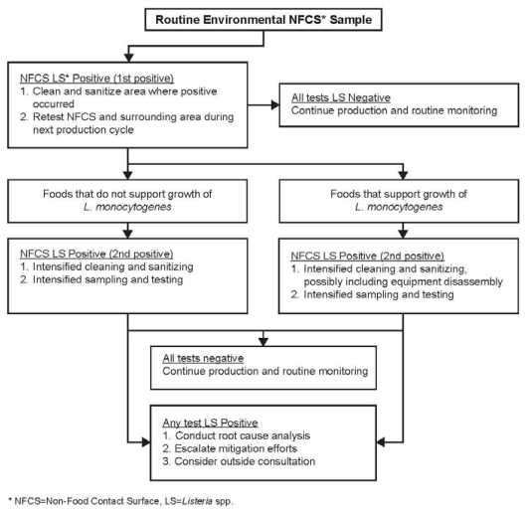
    - Food Contact Surfaces (Zone 1) Process Flow

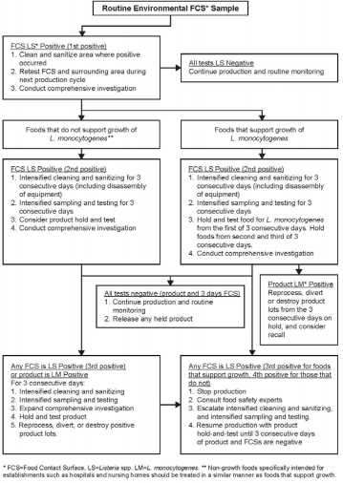

    - Salmonella Detection
      - Zone 1
        - Product should always be placed on hold if zone 1 Salmonella testing is to be done.
        - Quarantine the suspect area and limit access to that area.
        - Break down the line from the initial positive site on for visual inspection, additional vector sponge/swab sampling, and cleaning and sanitation activities.
        - Conduct vector sampling in zones 1, 2, and 3 around the area of the initial positive result prior to cleaning. Precaution should be taken not to spread contamination to other areas of the plant.
        - Thoroughly clean and sanitize the line and surrounding area using dry, controlled wet, and/or wet cleaning procedures appropriate for low moisture environments.
        - Conduct pre-operational inspections on the line equipment and area prior to start-up and take additional vector samples of the area prior to start-up. It is highly advisable not to start-up the line until all vector sampling results are obtained (if the line is started prior to obtaining all vector sampling results, then product must be put on hold until negative results are obtained).
        - Increase the frequency of intensive sampling of the line and adjacent areas from weekly to daily (zones 1 – 3). After three consecutive days of negatives are obtained, the normal routine EMP sampling plan may be reinstituted
        - The response team should make a careful decision on disposition of finished product that is put on hold as a result of a zone 1 positive Salmonella finding. All finished product from full microbiological clean-up/sanitation to full microbiological clean-up/sanitation must be addressed by the team. Product should be re-worked, if possible, or condemned according to all legal and regulatory statutes. It is not an acceptable practice to test lots of finished product for Salmonella in response to a confirmed zone 1 result for the purposes of releasing product.
      - Zone 2
        - Stop production and prepare the system for cleaning and sanitation.
        - Quarantine the suspect area and limit access to that area.
        - Break down the line from the initial positive site on for visual inspection, additional vector sponge/swab sampling, and cleaning and sanitation activities.
        - Conduct vector sampling in zones 2, and 3 around the area of the initial positive result prior to cleaning. Precaution should be taken not to spread contamination to other areas of the plant.
        - Thoroughly clean and sanitize the line and surrounding area using dry, controlled wet, and/or wet cleaning procedures appropriate for low moisture environments.
        - Conduct pre-operational inspections on the line equipment and area prior to start-up and take additional vector samples of the area prior to start-up. Do not restart the line until satisfactory vector swab results have been obtained.
        - Increase the frequency of intensive sampling of the line and adjacent areas from weekly to daily (zones 2, 3). After three consecutive days of negatives are obtained, the normal routine PEM sampling plan may be reinstituted.
      - Zone 3
      - The response team should make the decision whether or not to stop production based on the proximity of the initial positive site to product contact areas.
      - Quarantine the suspect area and limit access to that area, if feasible.
      - Visually inspect the area and conduct additional vector sponge/swab sampling prior to cleaning and sanitation activities.
      - Conduct vector sampling in zones 2, and 3 around the area of the initial positive result prior to cleaning (zone 2 sampling is done to ensure that contamination has not spread closer to open product areas). Precaution should be taken not to spread contamination to other areas of the plant.
      - Thoroughly clean and sanitize the area (at least a 50-foot radius, if possible) using dry, controlled wet, and/or wet cleaning procedures appropriate for low moisture environments.
      - Conduct pre-operational inspections on the line equipment and area prior to start-up and take additional vector samples of the area prior to start-up. Do not restart the line until satisfactory vector swab results have been obtained.
      - Increase the frequency of intensive sampling of the line and adjacent areas from weekly to daily (zones 2, 3). After three consecutive days of negatives are obtained, the normal routine PEM sampling plan may be reinstituted.
      - Zone 4
        - A Salmonella positive finding in a zone 4 location does not implicate finished product, but it does provide information on non-production areas and the potential for spread of contamination throughout the facility.
        - Quarantine the suspect area and limit access to that area, if feasible.
        - Visually inspect the area and conduct additional vector sponge/swab sampling prior to cleaning and sanitation activities.
        - Conduct vector sampling in selected zone 3 areas adjacent to the location of the initial zone 4 positive location, if appropriate, and zone 4 sites around the area of the initial positive result prior to cleaning (selected zone 3 sampling is done to ensure that contamination has not spread closer to open product areas). Precaution should be taken not to spread contamination to other areas of the plant.
        - Thoroughly clean and sanitize the area (at least a 50-foot radius, if possible) using dry, controlled wet, and/or wet cleaning procedures appropriate for low moisture environments.
        - Take additional vector samples of the area after cleaning and sanitation to verify effectiveness of those procedures.
        - Increase the frequency of intensive sampling of the areas from monthly to daily (zone 4 and selected zone 3 areas adjacent to the location of the initial zone 4 positive). After three consecutive days of negatives are obtained, the normal routine PEM sampling plan may be reinstituted.
  - Detection in Finished Product
    - Detection of L. monocytogenes in Food
      - Reprocess with a validated listericidal control measure, divert to a use in which the food will not be consumed by humans or animals, send for use in food to be consumed by animals where appropriate, or destroy the lot(s) of RTE food in which L. monocytogenes has been detected. Consider lots produced between two cleaning and sanitizing cycles to be implicated by the product positive.
      - Determine whether other lot(s) of food are potentially contaminated with L. monocytogenes and segregate and hold those lots of food. Review environmental monitoring results to determine if other lots could be contaminated. Subject potentially contaminated lots to “hold and test” procedures, reprocess with a validated listericidal control measure, divert, or destroy any lot of RTE food in which L. monocytogenes is detected. Corrective actions regarding your plant and your procedures include intensified sampling and testing of FCSs and non-FCSs, followed by the corrective action until the source of contamination is found and eliminated. Determine whether food in commerce would be subject to a recall.

3. History
Revision No.: | Revision Date: | Description of Change: | Originator / Author Name: | Title / Department:
0 | YYYYMMDD | Original | ENTER AUTHOR NAME | ENTER TITLE / ENTER DEPARTMENT

Requirements:
- The trainee (employee/visitor) has read or received a verbal translation of all or part of the policy, procedure, method, and/or SOP for which they are being trained.
- The trainee has observed a demonstration of the task they are to perform or the procedure for which they are being trained as required.
- The trainee has demonstrated the ability to perform the task with acceptable proficiency and minimal supervision.

TRAINEE (Print Name): | TRAINEE (Signature): | Date: | Department:
Trainer / Supervisor (Print Name): | Trainer (Signature): | Date: | Department:

*Should you need assistance in customizing this document please email services@consultareinc.com

